St. George Melkite Patriarchate Church in Zababdeh, Holy Land

“Adopt a Child” Program

The Children Listed as Families

These children and their parents are active members of St. George Melkite Patriarchate Parish in Zababdeh. They attend weekly Divine Liturgy and Eastern Christian Formation (Sunday school). In addition, they attend parish social activities. These “Living Stones” love their church and they are the future of the Patriarchate Church in the Holy Land.
All of the children listed need support: spiritually, emotionally, socially, intellectually, and physically. These children range in age from 2 years old to 15 years old. Some details about the children are below.
These children are listed by family. Now, families, not individual children, are selected. Why? From experience, we learned that listing the children separately caused negative feelings within the families:
- Having only one or several of the siblings listed.
- Having only one or several siblings selected.
- Having the selected siblings receive very different amounts of financial support.
- The listed sibling, whom the parents thought most needed financial support, was not selected, while other siblings were selected.
Legally and morally, the financial support donated for a specific child must go to that child and only to that child. That financial support cannot go to a sibling. This fact caused negative feelings within the families.
Now, the financial support donated for a specific family goes to that family and only to that family. But, now, the parents can use their wisdom and judgment in dividing the financial support between siblings.
These children hope to attend the Latin Patriarchate School thru the twelfth grade. They will graduate about the age of 18.

Family #1 Abou Ebed family has 8 children: 7 girls and 1 boys

Only 2 children are being presented. One child is in a school at a Catholic Convent in Jerusalem. The other children are in the Latin Patriarchate School.

Father: Works as a janitor.
Mother: No paying work.

Ranna | Mariam
Age: 10 years old  School Latin Patriarchate School  Needs: | Age: 8 years old  School Latin Patriarchate School  Needs:

Family #2 Abou Khannam Family has 5 children: 4 boys and 1 girl

Only 1 child is being presented.
This boy wants to be a Melkite priest. He was accepted in the Minor Seminary portion of the Melkite Seminary in Beit Sahour for the Fall of 2007. But, the Seminary situation changed. The Melkite Seminary is closed and the applicants for the Melkite priesthood are to attend their local grammar and high school and then, they are to attend classes taught by the Catholic priests in their area.
He became a Melkite. His family is Anglican and attends the Anglican Church.

Father: Works in a hotel in Nablus
Mother: No paying work.

Nabil
Age: 16 years old
School: Latin Patriarchate School
Plans to become a Melkite priest
Needs: School fees and supplies

Family #3 Aouad family has 5 children: 4 girls and 1 boys

Only 1 child is being presented, the boy. The girls attend the Latin Patriarchate School.

Father: Works as an iron man. He lost his job in Iraq.
Mother: No paying work

Reed
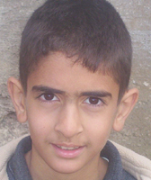
Age: 13 years old
School Latin Patriarchate School
Needs: School fees and supplies

Family #4 Barham family has 4 children: 4 boys

Only the oldest three children are being presented.

Father: Works about 10days in a month sewing
Mother: No paying work. She is sick. She has worked as a sewer. She was forced to stop her university studies.
Family: Very poor family and very active in the church.

Majd | Baha | Naeem | Sezar
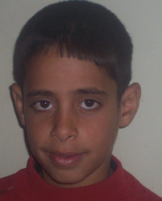 | 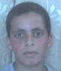 | 
Age: 13 years old  School: Latin Patriarchate School.  Needs: School fees and supplies | Age: 11 years old  School: Latin Patriarchate School  Needs: School fees and supplies | Age: 8 years old.  School: Latin Patriarchate School  Needs: School fees and supplies | Age: Born summer of 2006.

Diab is a common last name. On this list, there are 7 families with that name.

Family #5 Diab family Family has 3 children: 1 girl and 2 boys

Father’s name is Emad. Works as a builder
Mother: No paying work
Family: Very poor family. The church supports this family to buy food and clothes.

Mansour | Diab | Karoulin
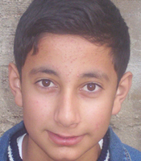 | 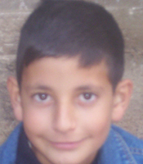 | 
Age: 17 years old  School: Latin Patriarchate School  Needs: School fees and supplies | Age: 14 years old  School: Latin Patriarchate School  Needs: School fees and supplies | Age: 12 years old  School: Latin Patriarchate School  Needs: School fees and supplies.

Family #6 Khoury Diab family has 4 children: 4 boys

Khoury is a title meaning “priest”. It is the custom for priests to add that title prior to their family name.

Father’s name is Firas: Works for the Catholic Church
Mother: No paying work

Boutros | Qusai and Kais | Elias
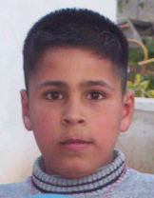 | 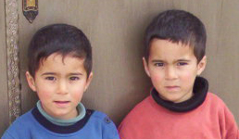 | 
Age: 14 years old  School: Government school  Needs: Home-schooling materials including textbooks and supplies. | Age: 7 years old twins  School: Latin Patriarchate Kindergarten  Needs: School fees and books | Age: 4 years old  School: Latin Patriarchate Preschool  Needs: School fees and books

Family #7 Diab family has 7 children: 6 girls and 1 boy
Only 1 child is being presented. She is the youngest child.
The married boy works for the government. One sister teaches at the Catholic School in Ramallah. Three sisters are at University.

Father’s name is Jarif: He works as a nurse.
Mother: No paying work
Family:

Yara
Age: 16 years old
School: Latin Patriarchate School
Needs: School fees and supplies

Family #8 Diab family Family has 3 children: 1 girl and 2 boys

Father’s name is Nabil: He is unemployed.
Mother: No paying work
Family: Very poor family. The church supports this family to buy food and clothes.

Narmen | Yazen | Udai
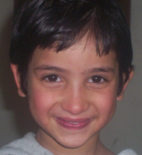 | 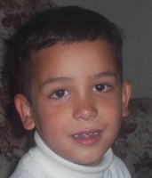
Age: 11 years old  School: Latin Patriarchate School  Needs: Food, clothes, school fees and supplies | Age: 9 years old  School Latin Patriarchate School  Needs: Food, clothes, school fees and supplies | Age: 8 years old  School Latin Patriarchate School  Needs: Food, clothes, school fees and supplies

Family #9 Diab family has 2 children: 1 girl and 1 boy

Only 1 child is being presented, the girl. The boy attends the Latin Patriarchate School.

Father’s name is Oudai: Works as a taxi driver. He does not own the taxi.
Mother: No paying work

Sherren

Age: 14 years old
School: Latin Patriarchate School
Needs: Food, clothes, school fees and supplies

Family #10 Diab family has 3 children: 2 girls and 1 boy

Only the oldest two children are being presented.

Father’s name is Salem: Works with water nets
Mother: No paying work

Loureen | Ouday | Mariam
 | 
Age: 9 years old  School: Latin Patriarchate School  Needs: School fees and supplies | Age: 8 years old  School Latin Patriarchate School  Needs: School fees and supplies | Age: 2 years old  Born Fall 2006

Family #11 Diab family has 4 children: 1girl and 3 boys

Father’s name is Yacoub: Works as a sewer.
Mother: No paying work

Sameh | Said | Raed | Ameel
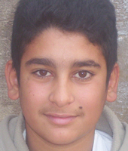 |  | 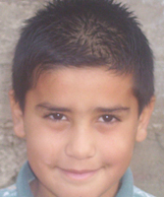 | 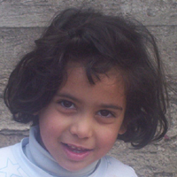
Age: 17 years old  School: Latin Patriarchate School  Needs: School fees and supplies | Age: 16 years old  School: Latin Patriarchate School  Needs: School fees and supplies | Age: 11 years old  School: Latin Patriarchate School  Needs: School fees and supplies | Age: 8 years old  School: Latin Patriarchate School  Needs: School fees and supplies

Family #12 Khader Family has 2 children: 2 boys

Father: Works as a sewer several days per month. His father lost his work in Israel.
Mother: No paying work

Raeed | Jamel
 | 
Age: 17 years old  School: Latin Patriarchate School  Needs: School fees and supplies | Age: 15 years old  School: Latin Patriarchate School  Needs: School fees and supplies

Family #13 Marwan family has 6 children: 3 girls and 3 boys

Only one child is being presented. The family only wanted to present one child.

Father: Worked as a nurse in a hospital. He lost his job
Mother: No paying work

Milad
Age: 8 years old
School
Needs: School fees and supplies

Family #14 Nicola family has 1 child: 1 boy

Father: Works as a workman several days in a month. Hs father lost his work in Israel.
Mother: No paying work

Khader

Age: 14 years old
School: Latin Patriarchate School
Needs: School fees and supplies

Family #15 Reammi family has 2 children: 2 girls and 1 boy

Only the oldest two children are being presented.

Father: Works as a teacher for the Palestinian National Authority.
He has not been paid his full monthly salary since February 2006.
Mother: No paid work

Vira | Justine | Daniel
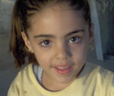 | 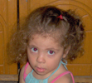
Age: 8 years old  School: Latin Patriarchate School  Needs: School fees and books | Age: 6 years old  School: Latin Patriarchate School Kindergarten  Needs: School fees and books | Age: 2 years old  Born in Fall 2006

Family #16 Said family has 7 children: 5 girls and 2 boy
Only 1 child is being presented.
The oldest child, a boy, attends a university. The girls attend the government school.

Father: Does not work. He is sick
Mother: Works half day in a kindergarten
Very poor

Uday
Age: 7 years old
School
Needs: School fees and supplies

Family #17 Saegh family has 1 child: 1 boy

Father: Works as a policeman for the Palestinian National Authority
He has not been paid his full monthly salary since February 2006.
Mother: No paying work. She was forced to stop her university studies.

Faris
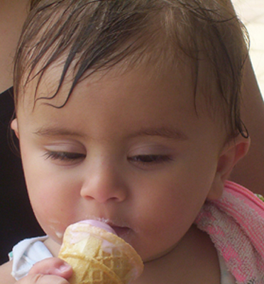
Age: 4 years old
School: Latin Patriarchate School Preschool
Needs: School fees and supplies

